**To configure DNS server**

Click on start button select administrator tools and click on DNS  
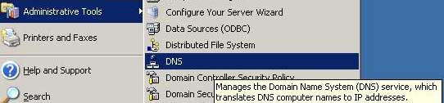

If you do not see the DNS option in Administrator tools sub menu it means you haven't installed it. See our previous article to installed it.

In left pane expand the Server. Here you can see default forward and reverse zone which were configured during the ads configuration. Delete the defaults zone files.

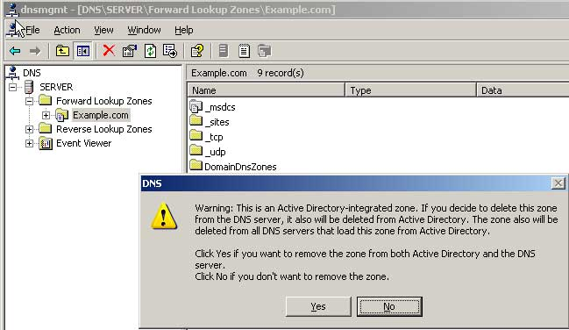

Make sure you remove both forward and reverse lookup zone files before start configurations

Now we will create new forward and reverse zone file for DNS.

Right click on forward lookup zone and select new zone files  
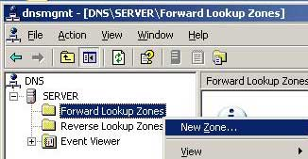

Click on next on welcome screen   
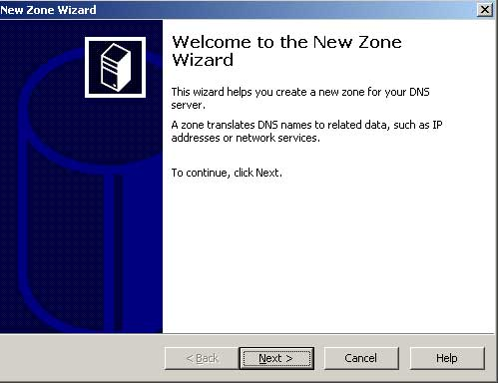

Select primary zone.  
We need not to store zone in ADS so Remove check mark from Store the zone in Active Directory  
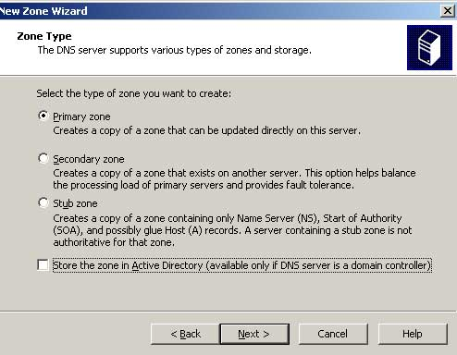

Give a relative name for this zone file. For local network we suggest you to give your domain name for this zone file.

Our domain is Example.com so I set Zone name to Example.com  
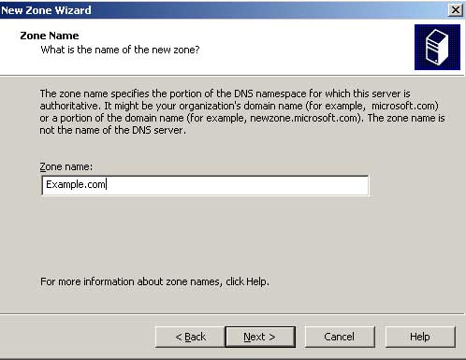

We are creating first zone So select Create a new file with this file name, do not change default name just click on next  
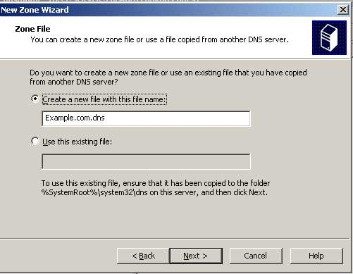

We are going to use this DNS server in local network so select Allow both nonsecure and secure dynamic updates. Don't use this option in public network.  
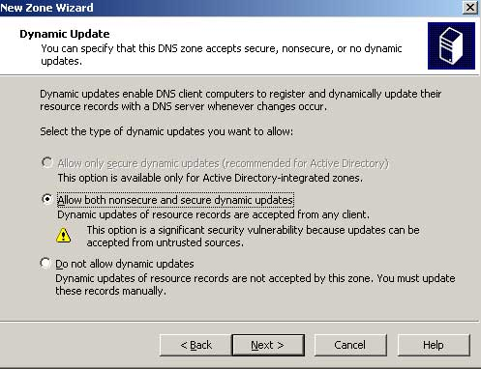

On summary table just click on finish  
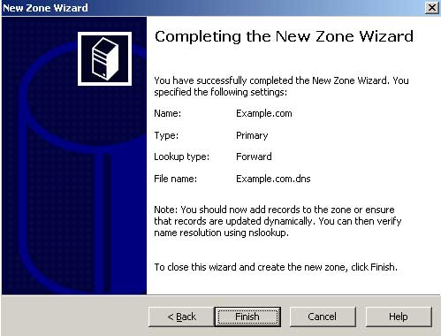

**Configure Reverse Look up zone**

We have configured Forward look up zone. Now we need to create Reverse look up zone before we use it.

Do Right click on Reverse Lookup zones   
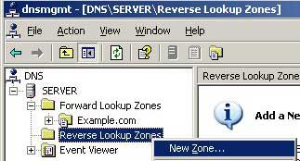

On welcome screen click on Next   
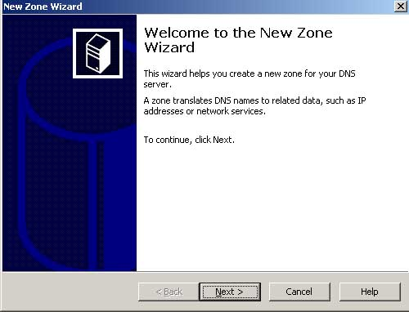

Select primary zone.  
We need not to store zone in ADS so Remove check mark from Store the zone in Active Directory  
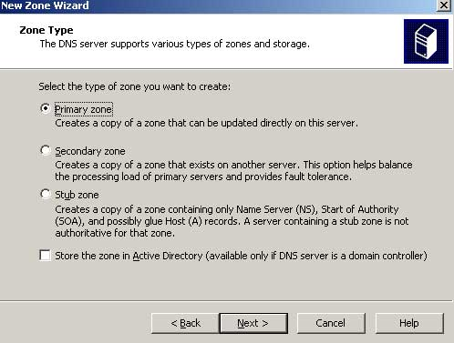

Give the network ID from the IP address of server. Our server IP is 192.168.0.1 so I will set here 192.168.0 [ network partition of IP]   
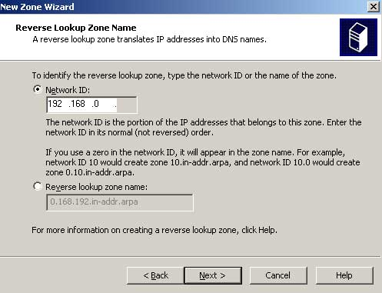

Keep the default name for zone file and click on next   
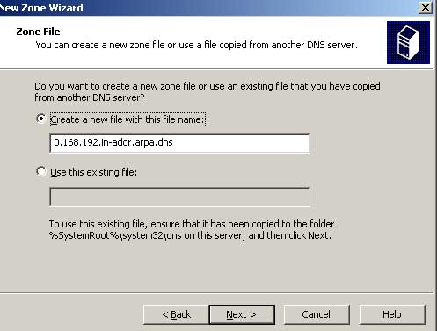

Select Allow both nonsecure and secure dynamic updates. Don't use this option in public network.  
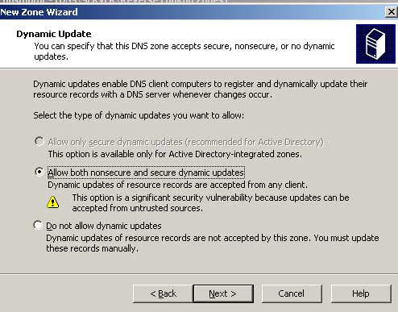

On summary table just click on finish  
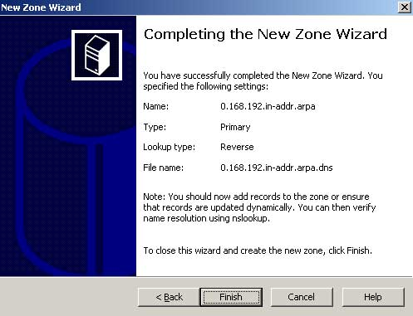

We have created both zone file for DNS server. Now we need to tell DNS server about our pointer for DNS server.

Expand Reverse Lookup Zones and select 192.168.0.x Subnet [ if you have used different ip for server then here you will find your IP address's subnet ].

Right click on it and select New pointer  
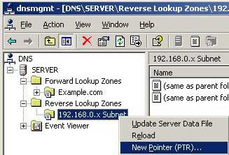

Now give the host ID from IP address. We will give 1 as we are using 192.168.0.1 ip address.   
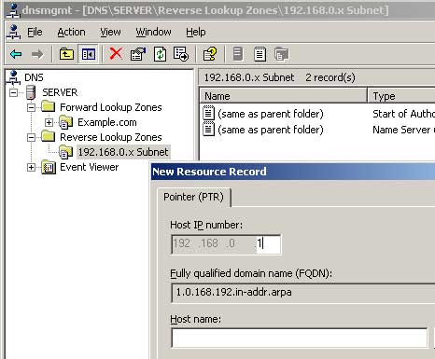

At this point we have configured both forward and reverse lookup zone. But all these effect will take place after restart of DNS. DNS service can be restart in two ways either by restarting the service or do a complete restart of server.

To restart the DNS service Right click on Server and select restart from all task  
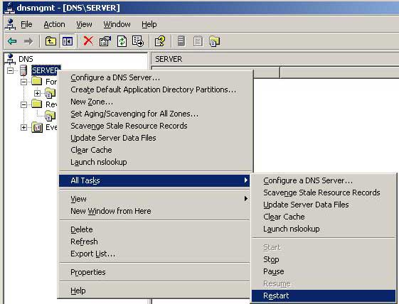

Configuration of DNS server can be verify by launching nslookup. To launch nslookup right click on Server and select nslookup  
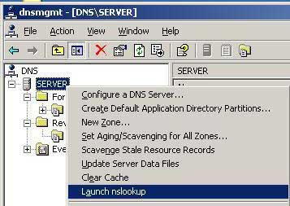

If you see the default server name in output mean DNS server has been properly configured and functioning. But we haven’t restarted the server so you will not see the server name here.

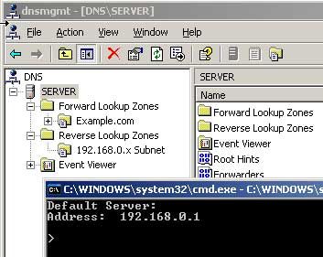

To apply all these change Restart the server, After Restart verfiy it again and you will see default server name in nslookup

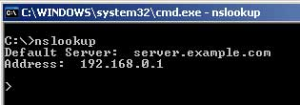

Additional testing of DNS can be done by pinging it by name. Go on any client computer and ping the DNS server. *[ Before doing this set preferred dns ip to 192.168.0.1 on client.]*

